|  |  |  |
| --- | --- | --- |
| Sprint review - **Increment Five dELIVERY** | | |
|  | | |
| **Location:** | Google Meets |  |
| **Date:** | October 28, 2020 |  |
| **Time:** | **9:00 PM** |  |
| **Facilitator:** | Baheshta Abed |  |

# Attendees:

Mashall Addeel, Sayed Manshour Sadat, Masuoma Tajik and Mahdi Alizada.

**Meeting Purpose:**

The purpose of this meeting was for the Development Team to present the fifth and final increment for the Product Owner to either approve or reject or give feedback for any changes.

**Below are the events that took place in the meeting:**

The Scrum Master welcomed everyone and requested Sayed Manshour, member of the Development Team to begin the presentation if he was ready.

It is important to note that throughout the project and during each Sprint, the Scrum Master did conduct Daily Sprints via Facebook Messenger, in order to keep a track of the tasks being done accurately based on the Product Owners’ demand (i.e. the user stories). Below are the Sprint Backlogs as well as the Burn Out Chart for the fifth Sprint.

Burn Out Chart



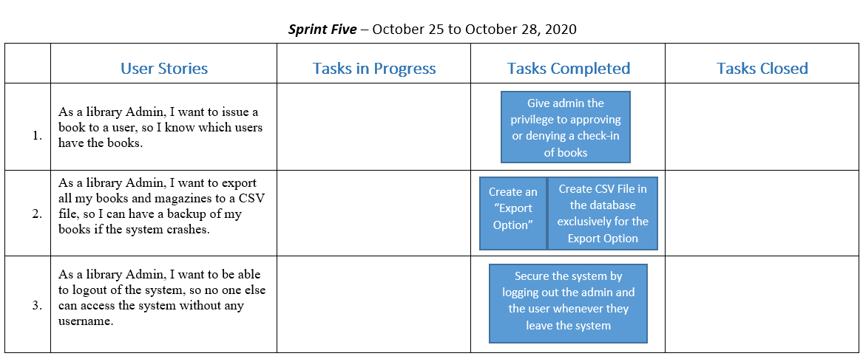

**Sprint Backlogs** were updated every day throughout the Sprint.

Day 2 of Sprint V

Day 3 of Sprint V

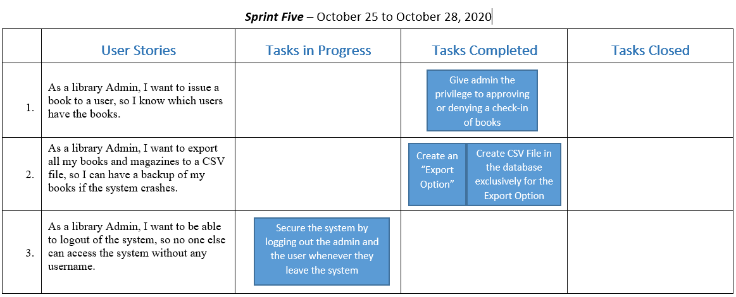

Fortunately, the Product Owner was yet again satisfied with the outcomes. She tested the system by herself and fully approved the fifth and last increment. She thanked the Team and the Scrum Master for their hard and consistent work and the Scrum Master too thanked the Team as we all the Product Owner for her support and guidance. Since the Product Owner fully approved of all the increments, she did not need a final presentation of the whole system and was satisfied with all the deliveries and congratulated the team on their brilliant work.